Week 10 Advanced Robotics - Gaussian Mixture Regression  
and Stable Estimator of Dynamical Systems

Athanasios Polydoros May 8, 2022

Today’s topics

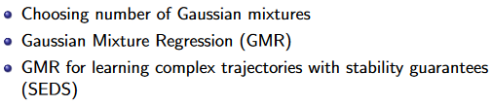

**Optimal number of Gaussian**

We used likelihood function tom measure accuracy of the model

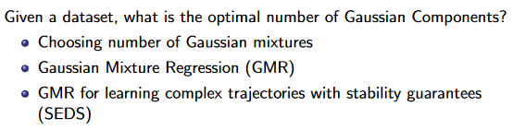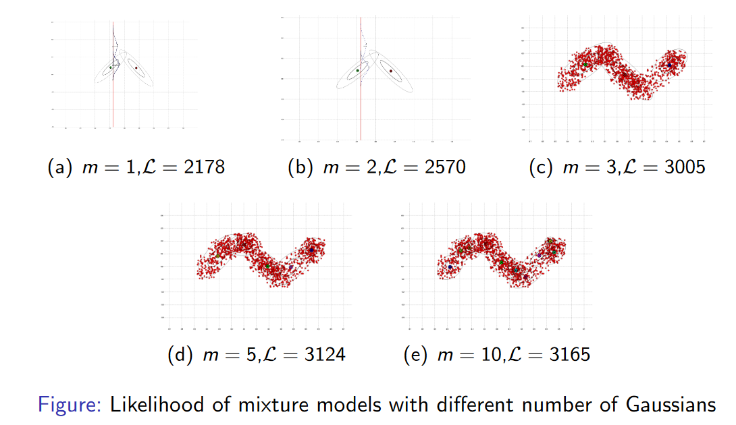

How to choose the optimal number of Gaussians?

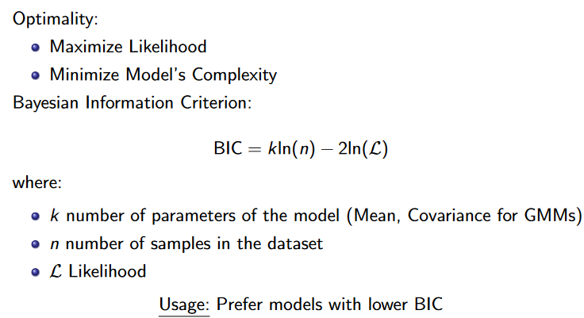

This gives a trade-off between complexity and likelihood, we want a model with very low bayesian criterion. the parameters of gaussian is mean and covariance

12 parameters if we have 2 Gaussian in a 2 dimensional space.

**Using BIC**

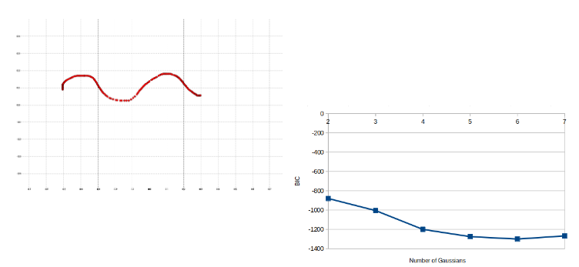

The rate of change of the BIC is minimal at 6 so we can pic either 5 or 6.. We read the graph by taking the clear minimal value but if the minimal is not clear then we pick the closest thing.

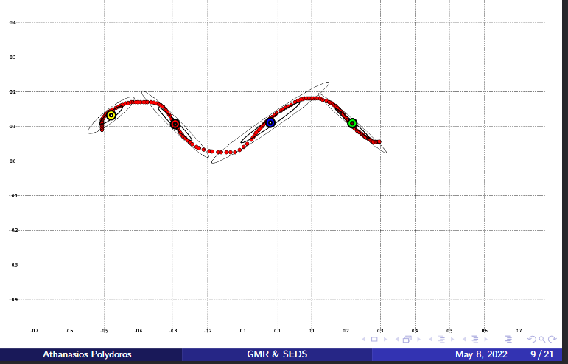

Regression with Gaussian Distributions

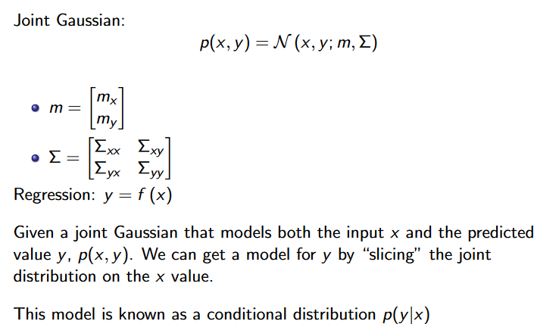

Regression with single Gaussian Distribution

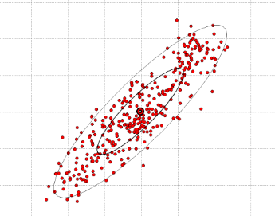

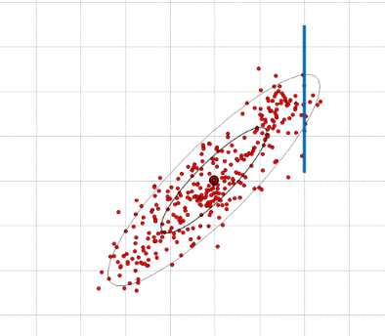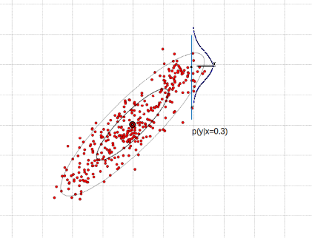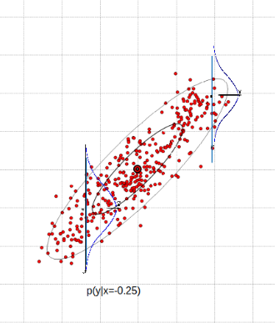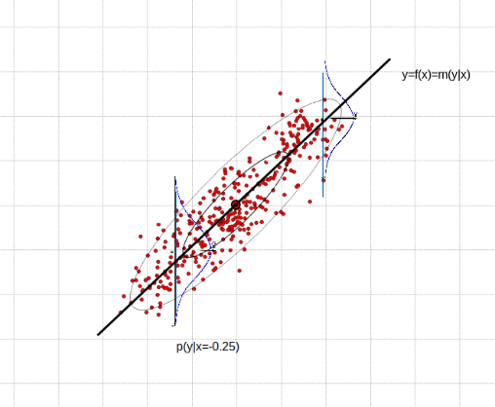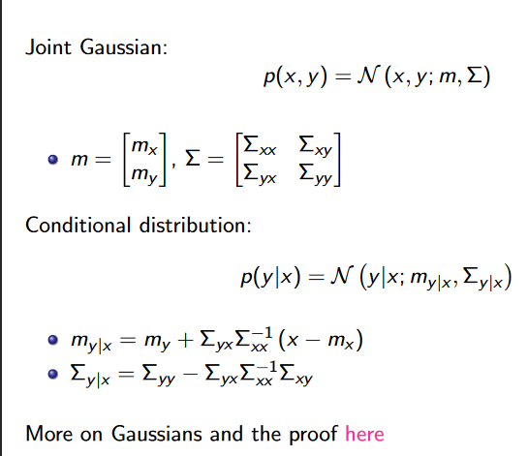

P(y/x) represents the slope, how steep our line is

**Regression with Gaussian Mixtures 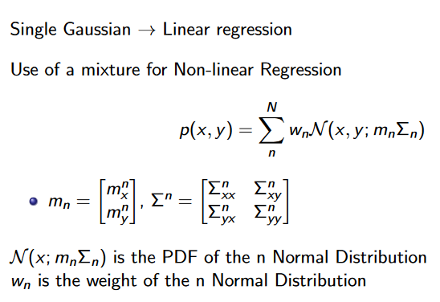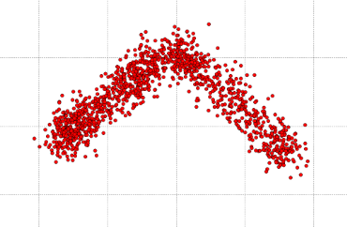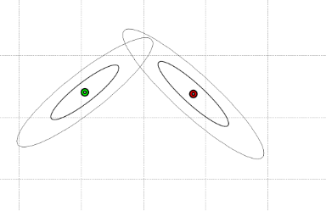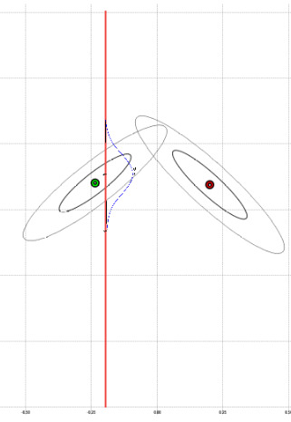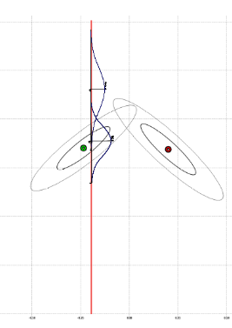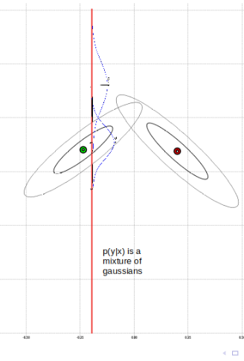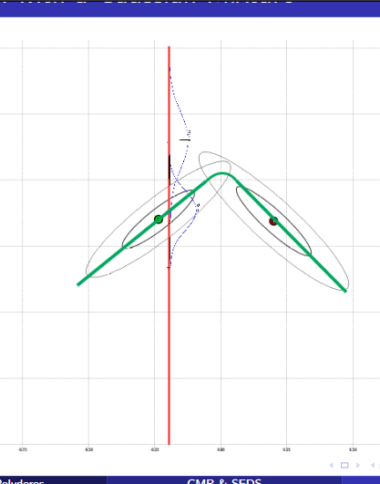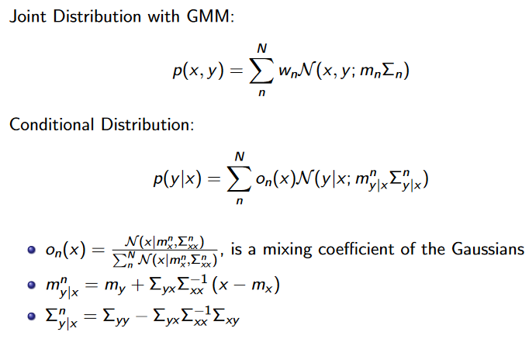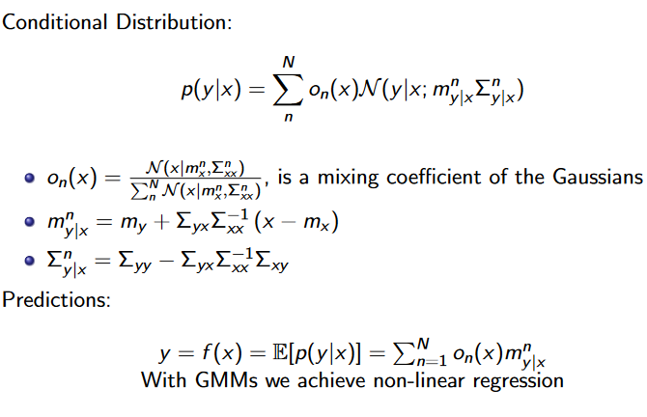Stable Estimator of Dynamical Systems –SEDS**

